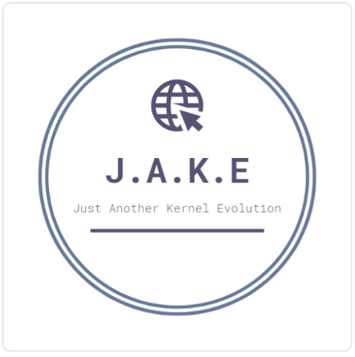J.A.K.E

Team Charter

# Purpose Statement and Team Objectives

J.A.K.E consists of talent engineers and leaders committed to working effectively as a team and helping one another to learn. Our objectives are blah blah

# Analysis of Strengths and Developmental Needs

In determining a common set of performance goals, we analyzed the skill sets of all team members in relation to nature of the work we have to complete. We identified background, experience and the complementary skills of each and defined individual levels of accountability.

# Strengths:

*Knowledge and Skills*

The team is diverse in many technical areas. Prior to joining J.A.K.E, we have dealt with technology ranging from test automation to microservices. We take great pride in our willingness and capability to learn and use modern technology. Our specialty is on the web platform using single page application libraries, publisher-subscriber architecture, and persistent data storage.

*Background and Experience*

We are a healthy mix of cultural backgrounds that has served to improve our awareness and perception of the competition. Our team members have several years of experience in the industry.

*Interpersonal Skills*

The team works well together with expectation levels kept in sync. We all contribute without no one dominating. Specifics roles and responsibilities are established up front and we instilled a disciplinary structure.

# Development Needs:

*Lack of formal training as a liaison between stakeholders and team*

An understanding of management techniques and principles will be helpful in completing this project. This is an area our team members have not had exposure in. To overcome this limitation, the team will study literature on project management and combine with our technical experiences to effectively communicate the needs between the team and clients.

# Team Members and Functional Roles

|  |  |  |
| --- | --- | --- |
| **Team Member** | **Role and Contact Info** | **Responsibilities** |
| Ethan Thomas Uong | Product Manager  etuong@gmail.com | Work with customers and stakeholders to define the product direction. Manage backlogs and maximize the product's value to the business. Overseeing the product vision and strategy to lead cross-functional team from product's conception to deployment. |
| Ethan Thomas Uong | Product Manager  etuong@gmail.com | Work with customers and stakeholders to define the product direction. Manage backlogs and maximize the product's value to the business. Overseeing the product vision and strategy to lead cross-functional team from product's conception to deployment. |
| Ethan Thomas Uong | Product Manager  etuong@gmail.com | Work with customers and stakeholders to define the product direction. Manage backlogs and maximize the product's value to the business. Overseeing the product vision and strategy to lead cross-functional team from product's conception to deployment. |
| Ethan Thomas Uong | Product Manager  etuong@gmail.com | Work with customers and stakeholders to define the product direction. Manage backlogs and maximize the product's value to the business. Overseeing the product vision and strategy to lead cross-functional team from product's conception to deployment. |

# Team Process Management

# Decision Making Procedure:

https : ==www:mindtools:com=pages=article=newTMM79:htm

Read this and make something up

# Team Communication:

We will communicate with each other through various means. Our primary form of communication is mobile and emails and we plan to hold weekly video session. Prompt responses to messages/inquiries from one another are expected. A member is responsible for effective communication if they are unable to deliver as promised and advise the team alternative arrangements if possible.

# Assessment of Team Effectiveness

At the end of each submission including the three presentations and five documents, the team will conduct a review that will address a few questions and assess our effectiveness.

Discussion of our effectiveness in relation to our stated objectives may raise questions such as “Did we meet our goals?” or “Are we where we need to be in order to complete our work on time?”

Discussion of our effectiveness at working together may involve a team feedback survey. We will make adjustments based upon our reviews and set improvement goals to guide subsequent efforts.

*Wow this sounds so bad, should clean it up*